A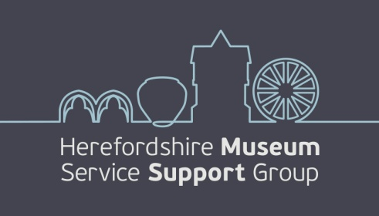 Registered charity no 1171756
History Store, 58 Friars Street, Hereford HR4 0AS

Annual Report April 2025 to March 2026

Report from Chair, Denise North
This year our Report will focus on events organised by HMSSG and the partnership working with Damian Etheraards and the team to support moving towards the redevelopment ambitions whilst maintaining business as usual. Much has happened in the last few months. As Trustees and committee members we work to ensure that our members and friends are kept abreast of new developments in cultural projects under the umbrella of Herefordshire Council. That such projects are important is in no doubt, their execution complex and lengthy also undeniable. These we will touch upon at our AGM on Monday 7th September. In past years the Annual Report has included input from Damian Etheraards on the team’s work on various projects and initiatives in the last year. This report contains a summary of the main thrust.

From April 2025 to March 2026 HMSSG has hosted events in order to boost our profile and remind the public of the importance of the county collections held for us all. In September we held our first event at HARC with Emalee Beddoes, Fine Art curator from the Museums and Galleries team who walked us through her personal highlights of the paintings collection. This proved extremely popular and we hope to have her talk to us again in the spring programme with another theme. I feel I don’t have much insight to the paintings held for us and it was really heartening to hear of the treasures whose prominence in the Broad Street gallery spaces will be welcome. Sash Giles, then House manager of Hellens, gave us insight on how important is this house whose history until well into the 1930s was not widely known. Sash has since moved on to another role and we wished her well as she left the county.
Elizabeth Semper O’Keefe, Cathedral archivist and old friend to us Friends, toured us through her cathedral archive highlights in A-Z order, with too many to choose in some cases! Her next talk will no doubt be delivered and scripted in Cyrillic alphabet or Esperanto!
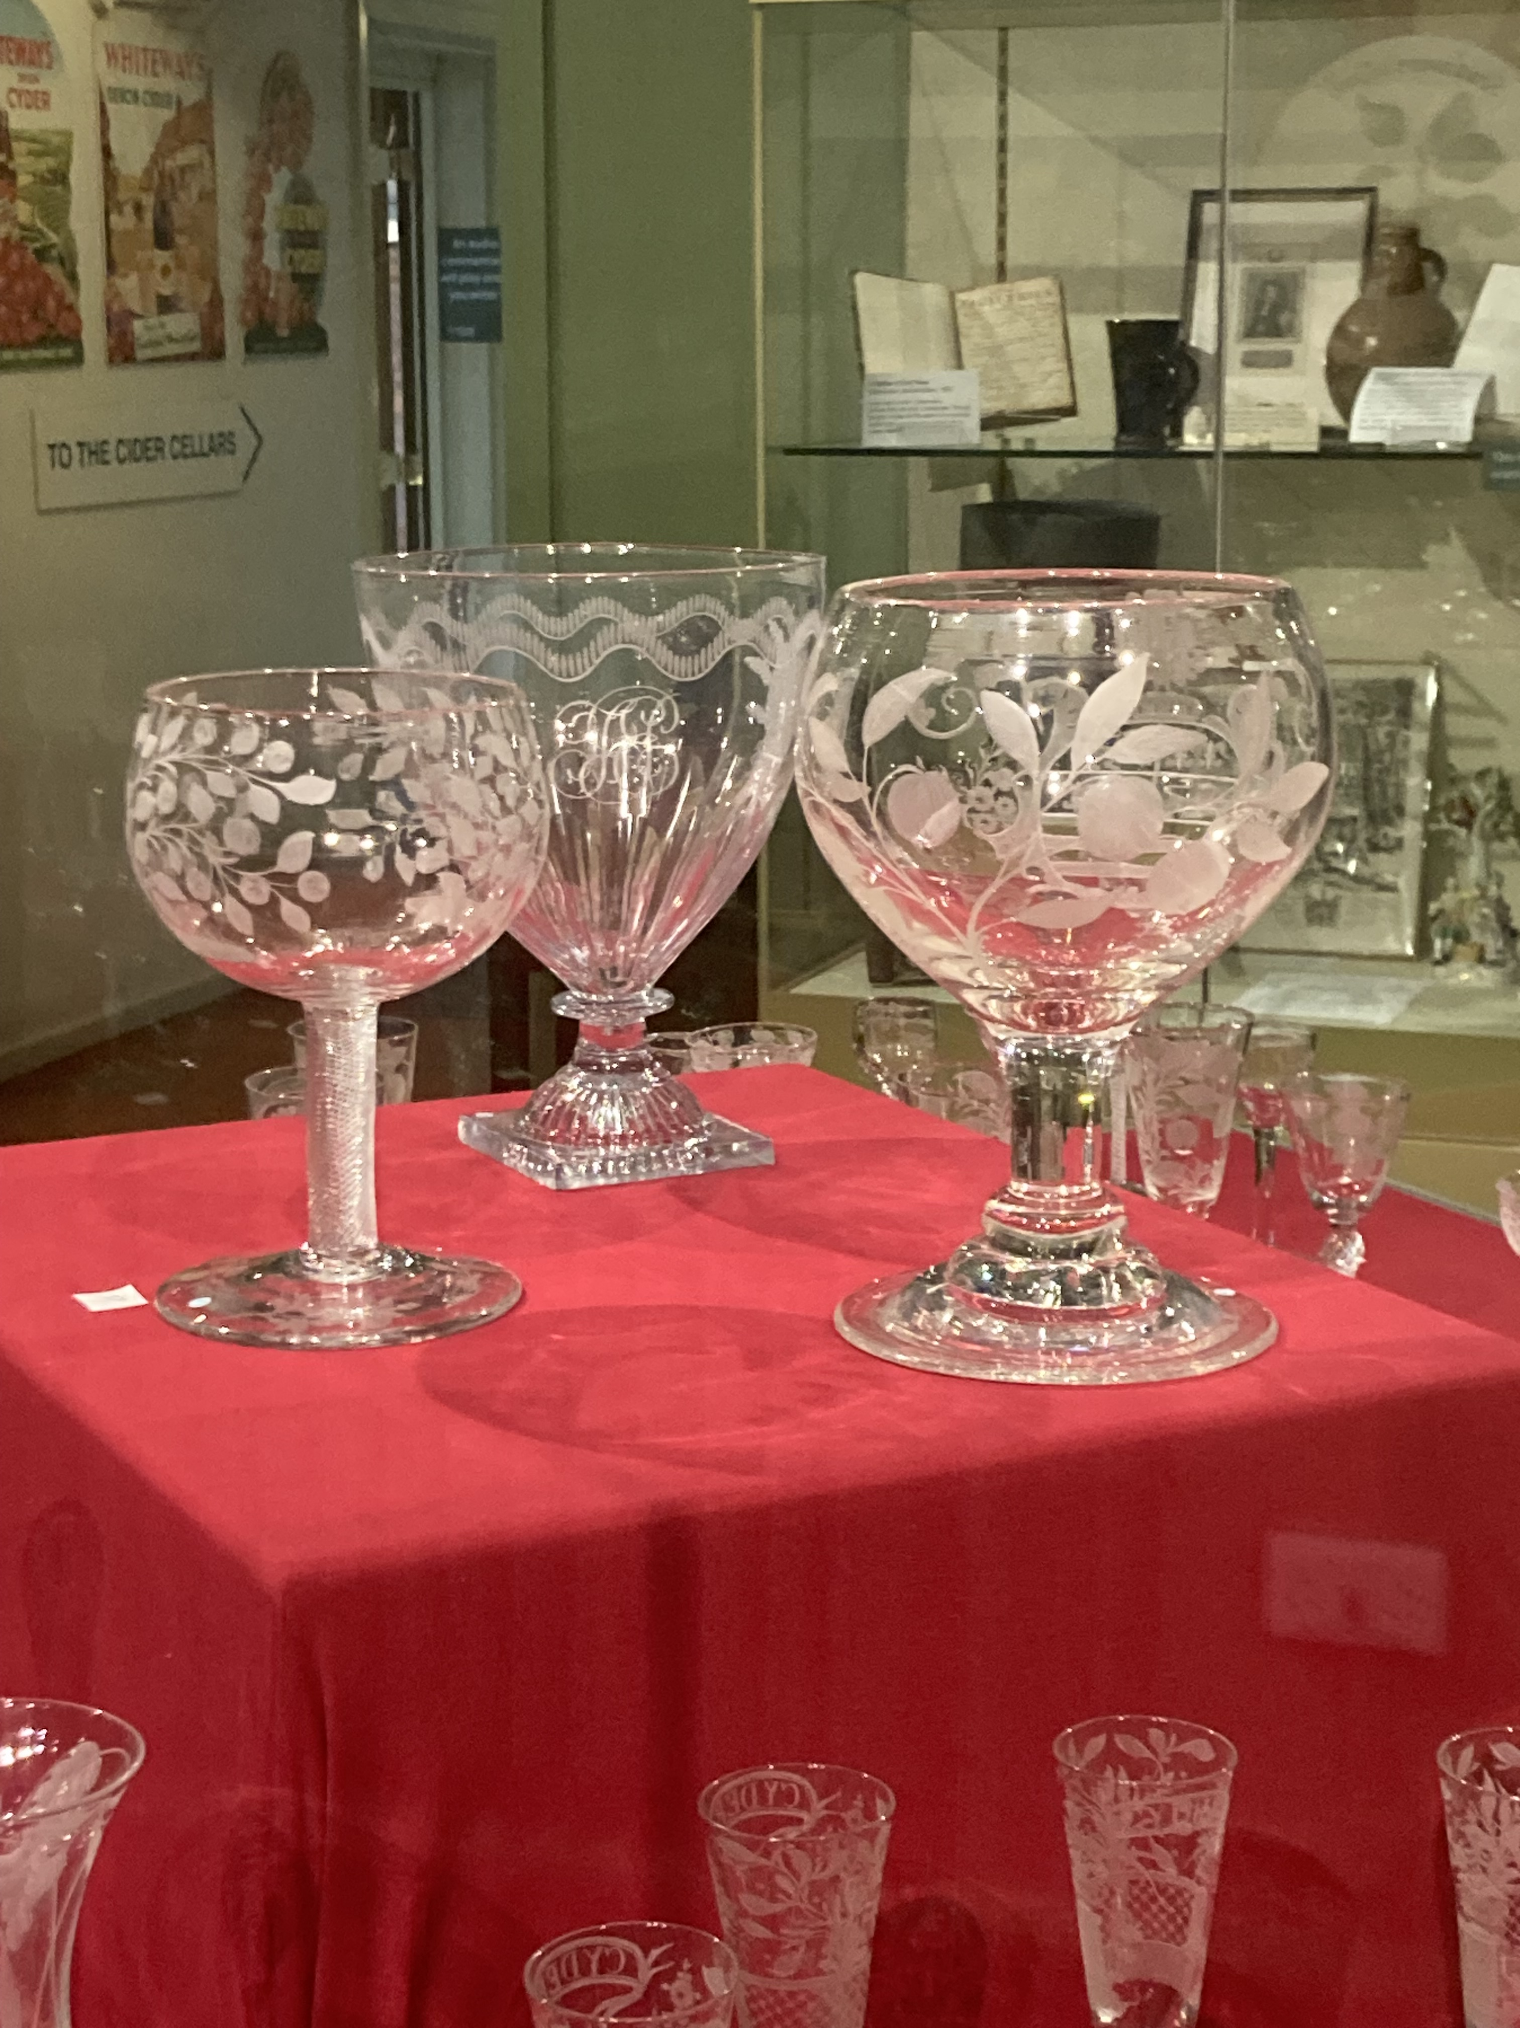
Our Trustee Elizabeth Pimblett whose knowledge of cider history, present and future is unsurpassed, gave us a well received two part experience, firstly in October with a comprehensive talk on Pomona’s Children - the art of cider from 1600s to today.
Highlighting how a humble thirst quencher for farm labourers rose to become a genteel drink of the noble class, whose roots in Britain spread abroad including to the US where the imposition of controversial duties on cider here spurred revolt in the American people. Their stand of no representation no tax led to major moves to resist distant feudal overseeing. That will never catch on surely! The second part of the experience had Elizabeth and Elisha Mason, Collection and Archive Officer at the Museum of Cider, lead a group through the history of the Museum Trust, the exhibition of beautifully crafted and rare drinking glasses and some of the quirkier artefacts from the collection. A chance to view the latest exhibition ‘Pop’ and hear of the building’s transition from Bulmer factory to museum and cider history repository completed the tour.

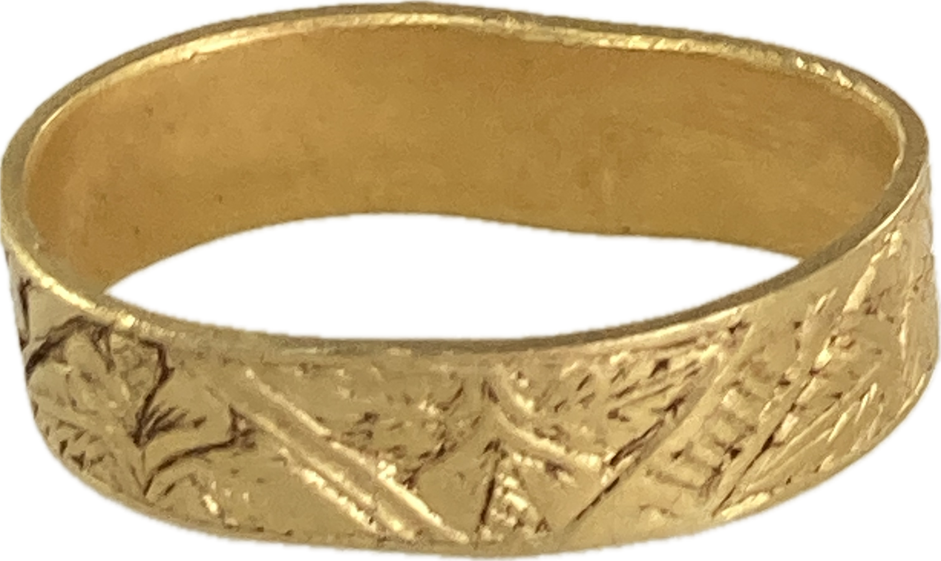
Amongst the visits and speaker events we have also supported the team with acquisitions. In April we were delighted to be invited to a private view of the Goodrich ring for which, along with our colleagues at Friends of Herefordshire Museums and Arts, we gave some funding to supplement that of the external grant bodies to purchase this pretty and delicate gold posy ring. Found close to the castle at Goodrich, this intricately engraved piece will be on display at our AGM for all to enjoy.

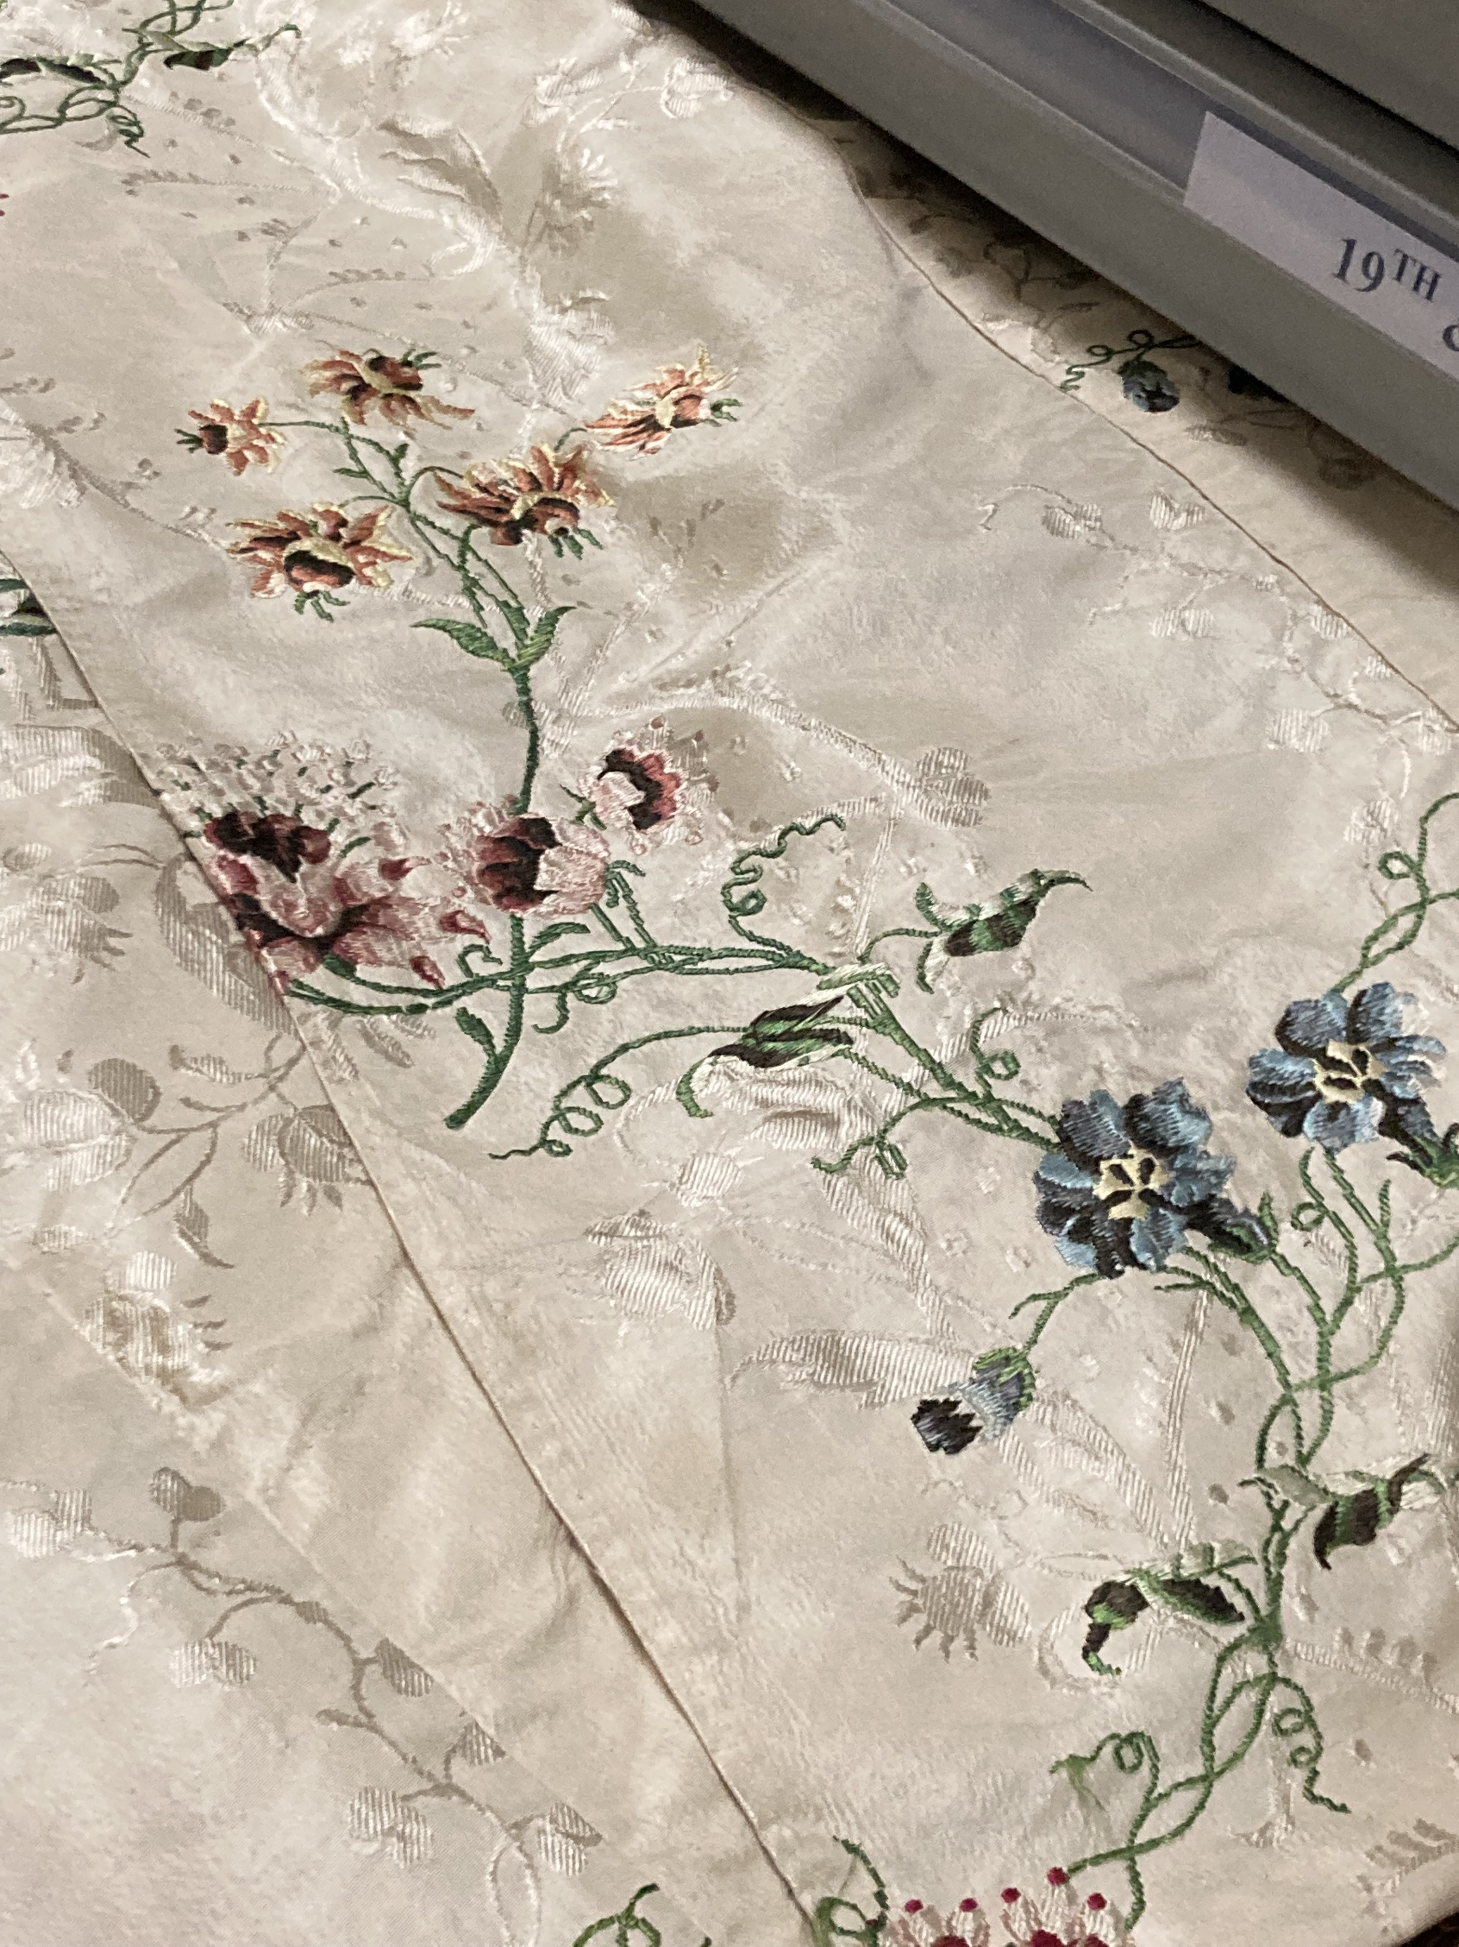
Though our most recent event falls outside the scope of this report, it is worthy of note. A small group affair with Sally Mansell giving a talk on the costume collection and its inception, the highlights and rarities. There will be a summary of this in our next newsletter and we plan to invite Sally to return to give the talk again next spring and dates for small group visits to the costume store. As one of the five most important costume collections in the UK we are eager to see selections of these in the redeveloped premises in due course.

As our members and colleagues will know, our main aim as the charity Friends of the Museums and Galleries is to support their efforts to care for and develop the collections held for us, the public and enable access to these as far as practicable. We act as advocates, ambassadors, critical friend and assist with funds, sometimes directly in the form of funding held by HMSSG, and others as applicant to grant bodies to whom local authorities may not be eligible to apply. You may be familiar with the Garfield Weston Foundation whose funds got the Hoard campaign over the line in 2022. After a request from Damian Etheraads, HMSSG agreed to apply to Garfield Weston Foundation for funds to help bridge the gap between the original funding garnered some years ago for the Broad Street redevelopment and the updated costs to be clarified late in 2025. The purpose of the funds was to support costs of shell and core element of the build, on the understanding that applications were to be made to other funding bodies.
The Trustees at Garfield Weston were receptive to an application but recommended applying at a level of one third that which had been anticipated. The monies were agreed on the premise that HMSSG as the applicant managed timely feedback by project officers from Herefordshire Council. The £250,000 was deposited in HMSSG’s account in November 2025. There it remains awaiting HC advising of the process to transfer funds to the HMAG redevelopment project accounts. As many of you will know, grant bodies have terms and conditions attached to their funding awards and Damian Etheraards was advised by Chair HMSSG that if no clarification was given as to the use of the funding by late 2026, HMSSG would advise the funder of the issues and delays to refreshed project costs, use of funds and timeline lag. This may result in funding being returned to GWF. As the responsibility for overseeing this money is with HMSSG, not Council, those discussions will be held as a matter of urgency.

Please see below the year end account for the charity. These show the £250,000 GWF grant monies. Our Treasurer, Christy Bolderson will take questions if there are any at the AGM.
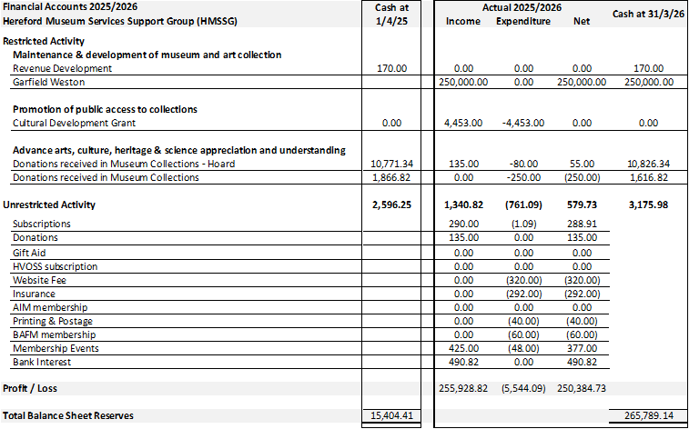

Our accounts and financial records have been examined once again by Giles May at MGMT. Thanks to him for his support.

What news of the Hoard also known as Hoard Two?
Along with the museums team, we await news from the DCMS Treasure Valuation Committee and their advisers on the target sum stipulated to acquire the tranche of Hoard coins, whose recovery was part of the Durham court case. Justice took its course and the perpetrators were jailed. The waiting continues however as until the valuation is given and the DCMS process starts, the Council then have to follow due internal process as to whether they wish to seek permission to acquire the coins as part of their internal processes. If so, grant applications will be made to national funding bodies with a cultural focus for a sum likely to be of similar amount to the first campaign, around £750,000. As in 2021-2 no Herefordshire Council funds will be included nor anticipated to meet the target but Officer time and resources to support the campaign will be their contribution. HMSSG will assist with the campaign as our resources allow but partly as as banker for public donations and potential grant applicant to agencies who will not accept local authority approaches.
Meanwhile, with the Broad Street building shuttered, the museum team continue to work to keep the show on the road – literally in the case of the recently launched Museum on the Move vehicle. Artefacts, Hoard replicas and educational toolkits and resources are proving popular attractions, with the education lead Lara Lourie’s busy schedule restoring a level of engagement with school age students not practical for several years. Hereford College of Arts students have had the chance to influence their local treasure house and make their mark as young artists in the making.
Community conversations with various groups have taken place to ensure those who tend to be not regularly in contact with historical objects and cultural outlets will feel they have had some chance to input to the designs for the Museum and Gallery. Experts in their fields formed a panel to advise on curatorial development for the Museum and Gallery and their influence will play a part in the redeveloped facility. What are we missing? Oh yes, a Museum and Gallery building open to the public, local and from further afield. As a place designed for all, we await and wait.
In the closing remarks after our speaker we shall bring you up to date on the current state of progress with HMAG redevelopment.
Once again I must thank my fellow Trustees and Committee menbrs for their support and engagement over the last year. We all face challenging times, inside and outside this organisation but teamwork and a focus make all the difference.

Denise North
Chair HMSSG

