The Old Barracks in Harold Street, Hereford, HR1 2QX – an Application for Listing
1. Introduction:
The Old Barracks in Harold Street, originally known as the Militia Depository, proudly announces its birth-date of 1856 on a keystone over its entrance. Since c.1960 it has also been used as the Herefordshire County Record Office, which is now installed in a new purpose-built archive centre, just outside Hereford, at Rotherwas. The Old Barracks have been well-maintained by Herefordshire Council and can clearly be expected to be adapted for other purposes. However, the building has no statutory protection – it is unlisted- and outside Hereford’s Central Conservation Area. Various proposals for the future use of the building – and its grounds –are under consideration. It lies in a residential suburb, which developed around it in the late 19thcentury. Naturally, the residents have strong ideas about its future use and appreciate that if it had listed building status this would inject some sensitivity into the development process and protect the integrity of the historic building and its setting. Moreover, the Army maintains a presence on the site within a purpose-built local hub for the Army Reserve Centre, which also contains the Herefordshire Regimental Museum.
2. The Historical Importance of the Building
A company of Herefordshire volunteers was raised during the Napoleonic Wars and was commanded by Col. John Matthews of Belmont, a retired surgeon and banker. It saw active service on the Continent. After 1815 the threat of social revolution persuaded the government of the time to retain the vestiges of a local militia, giving the county magistrates the necessary powers to support it from the rates. Accommodation for its officers and equipment, together with space for training, was to be provided in the new Shire Hall planned for Herefordshire in 1812. Sir Robert Smirke’s specification for the new building in St. Peter’s Square contained a militia building and a depot of arms. However, the former was to cost £16,000 and was quietly abandoned. However, the Depot of Arms, costing £3000, was constructed in the basement of the new building, which was completed in 1816. For the next 40 years the volunteers gathered for training at the Shire Hall but with an increasing burden of local government being placed upon the county magistrates, space in the Hall was at a premium. In the late 1840’s the Chief Constable of the new police force needed to be provided with office space. For the magistrates and judges who used the Shire Hall the volunteers were incongruous neighbours. When they were not marching around the curtilage of the building, they were up to no good in their basement depot. Apparently, they were constantly thrusting their bayonets into the lead piping, which fed water into the building and according to the County Chairman the piping was ‘riddled in 5000 places….to the great detriment of the premises’. A new depot became essential.
The military reforms following the Crimean War (1854-6) amplified the importance of the militia as a reservoir of trained troops. Already in 1852 the militia was converted into a permanent volunteer force, which was increasingly used for service throughout the Empire. Thus, in 1856 the Herefordshire magistrates borrowed £5000 on the rates and sought a site for a new purpose built Militia Depository. The Chief Constable moved into his office in the basement of the Shire Hall. A spacious site, with enough room for a parade ground was found to the east of the Castle Green, in the Bartonsham where new housing was already encroaching upon the Portfields that surrounded medieval Hereford. In January 1856 the area was defined by a brick wall, which cost £284 and the main building was completed in July 1857, together with a small stable-block for the officers.
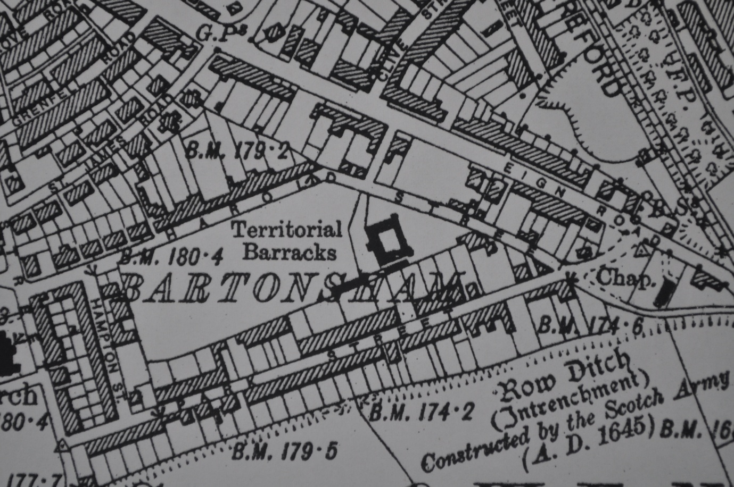
The site of the Militia Depot (Territorial Barracks) in Bartonsham 6” OS plan 1930

Soon after it was completed volunteers from Herefordshire were being recruited for service in India to restore British power after the Indian Mutiny. For the next century many young men, drawn from the farming communities along the Welsh Border, passed through this building and saw active service in the remotest parts of the world. Many never returned home and the Old Barracks stands as a monument to the common soldiers, who with joy and sadness, sustained British imperial ambitions in the late 19th and early 20th centuries.
3. The Building
The building was designed as a block-house – seven bays by five –under a low pitched slate roof with a central open courtyard. It was constructed in brick set on a low local sandstone plinth. It has the appearance of a modest late Georgian country house; its plainness reflecting its utilitarian purpose. As its name suggests it was designed as a storage depot for military equipment but as time passed it became known as the Barracks, perhaps providing transitory accommodation for volunteers being transferred to professional regiments or service overseas. The west façade remains as it was built with a central two storey porch, flanked by slightly projecting two bay wings. The porch was provided with military-looking rifle slots – now filled in -the one architectural embellishment that indicates its purpose. A diligent observer might also notice the faint dark bull’s eyes painted regularly on the west wall at about four feet from the ground either side of the porch. These were obviously painted for sighting practice when the Herefordshire Rifle Volunteers were founded in 1859. Either side of the porch are evenly spaced sash windows set in segmental headings. The original arrangements on the east front of the building have been masked by alterations made for the Record Office. The north and south facades retain the original arrangements and are regularly sashed like the west front. The interior arrangements, modified by the Record Office, seem to have been decidedly domestic and small scale. The enclosing wall of the parade ground can still be traced for much of its route albeit the Army Centre has opened up its frontage to Harold Street with iron railings. The officers’ stables can still be found in the eastern corner of the site and are used for storage. The building as it stands is an excellent example of a mid-Victorian militia depot, which must have once existed in every shire in the country but few remain today in a relatively unaltered state. Its domestic character epitomises the civilian context in which young men from the community were recruited to serve their country. Apart from the rifle slots there is little that is militaristic about the Harold Street barracks – England was not Prussia or France.
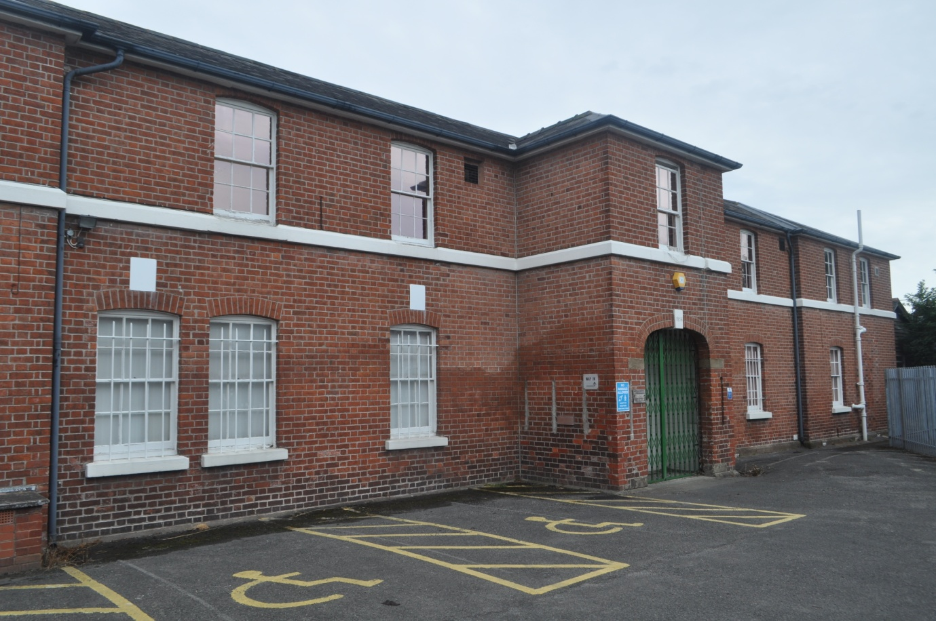
The west front of the Militia Depot – notice the rifle slots on the ground floor of the porch
4. The Architect
The militia Depository was designed by the county surveyor for Herefordshire, John Gray (1796-c.1862), who held the office from 1842-61. Gray was born in Ayrshire and came to Herefordshire to be clerk of works during the rebuilding of Hampton Court, Hope –under-Dinmore, from 1835-41. He established a private practice in the county as both a builder and architect at Veldifer Farm at Kings Acre. His domestic work included the restoration of Garnons (1849-50) and new houses at Pencombe Hall, Bodenham Hall and Staunton Park (1847). The last named was a late essay in Georgian symmetry, reminiscent of the style of the Hereford Militia Depot. He also designed schools at Weobley and Pencombe, a rectory at Stoke Lacy and restored the parish church at Bishopstone (1846). An important work in the city was the restoration of the Coningsby Hospital complex in 1854. Once he became County Surveyor his private practice dwindled. He had 149 county bridges to maintain and took up the post just at the time when new police stations and lock-ups were required all over the county. With the latter he was working from Home Office specifications but many of them survive today in one form or another. Sadly, it was the burden of his bridge-work that brought about his resignation as County Surveyor in 1861. Several bridges had been damaged by floods during the winter of 1860-1. A significant casualty was the Arrow Bridge at Pembridge, which required immediate attention and Gray commissioned a local builder to repair it. The work on the central arch was bodged and the local magistrates commissioned an independent investigation by the County Surveyor of Worcestershire, Henry Rowe, who found Gray negligent. Reluctantly, the magistrates accepted his resignation and he disappears from Herefordshire. For two decades he was very prominent in the county and the Militia Depot is a good example of his skill. He was not a top flight architect but produced competent and durable buildings for his parsimonious masters. Since the demolition of Staunton Park, the Hereford Depot provides evidence of his conservative taste.
5. The Case for listing:
(a) A familiar historic building in a suburb of Hereford is potentially threatened with mutilation or demolition. Listing will ensure that any changes carried out will be executed with sensitivity.
(b) The building is associated with a significant aspect of Victorian history. Essentially imperial policies relied upon the sacrifices made by the lower ranks of the British army. Here in Hereford we have evidence in the Militia Depot of the beginning of the story. The role of volunteer forces is often neglected in the official histories of the regular regiments of the British army. This is redressed in the survival of this building.
(c) The building survives in its entirety albeit with additions on its south side. The north façade is exactly as built and all the sash windows survive as designed on three sides. It is a very good example of a special building type and its conservative design tells us something about English military attitudes in the High Victorian era. Its character should be preserved during the next stage in its useful life.
(d) The architect, John Gray, has recently been given recognition in the new volume of the Buildings of England and his name occurs in the 2nd edition of Colvin’s Biographical Dictionary albeit lost in successive editions. He was a key figure in the architectural history of mid-Victorian Herefordshire. He worked tirelessly for the public good until his unfortunate encounter with the Arrow Bridge at Pembridge. The Militia Depot is an excellent example of his work , enhancing the streetscape of Victorian Hereford. Without this building the architectural quality of the Bartonsham suburb will be diminished.
David Whitehead – Hereford, 3rd August 2016

Hereford Journal (HJ) 14 May 1798, 4 July 1798; Uvedale Price, Thoughts on the Defence of Property (1797).
HJ 24 August 1814 – 26 April 1816.
HJ, 2 January 1856; Hereford Times (HT) 28 March 1857.
HJ 2 January 1856.
HJ 1 July 1857.
William Collins, A Short History of Hereford (1912), p. 133.
Christopher Pickford, ‘The County Surveyors of Herefordshire’ in Trans. Woolhope Natur. Fld. Club (TWNFC) (2010), p. 184.
Alan Brooks and Nikolaus Pevsner, The Buildings of England: Herefordshire (2012), pp. 549, 112, 605, 654, 610, 108, 339; at Garnons see David Whitehead in ‘Thomas Blashill, senior: land agent at Hampton Court and Garnons, c.1825-60’ in TWNFC (2016), forthcoming.
HT 5 January 1861, 23 February 1861, 3 August 1861. The porch with its date-stone

